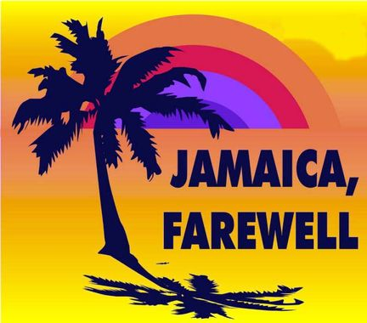
Jamaica Farewell- Harry Belafonte
1956- BPM 144- B-BH-HBH pour chaque accord
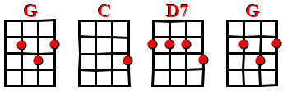
Intro : G C D7 G

Couplet 1

G C
Down away where the nights are gay
D7 G
And the sun shines daily on the mountain top
G C
I took a trip on a sailing ship
D7 G
And when I reached Jamaica I made a stop

Refrain
G C
But I'm sad to say I'm on my way.
D7 G
Won't be back for many a day.
G C
My heart is down my head is turning around.
D7 G
I had to leave a little girl in Kingston town.

G C D7 G

G C
Sounds of laughter everywhere.
D7 G
And the dancing girls swing to and fro.
G C
I must declare my heart is there,
D7 G
though I've been from Maine to Mexico

Refrain

G C
Down at the market you can hear,
D7 G
ladies cry out while on their heads they bear
G C
Akey rice and fish are nice
D7 G
and the rum is fine anytime o’ year

Refrain

Couplet 1

Refrain X2 enchaînés – 1er SANS G C D7 G- 2ème Sad to say… et G C D7 G

__v2_

